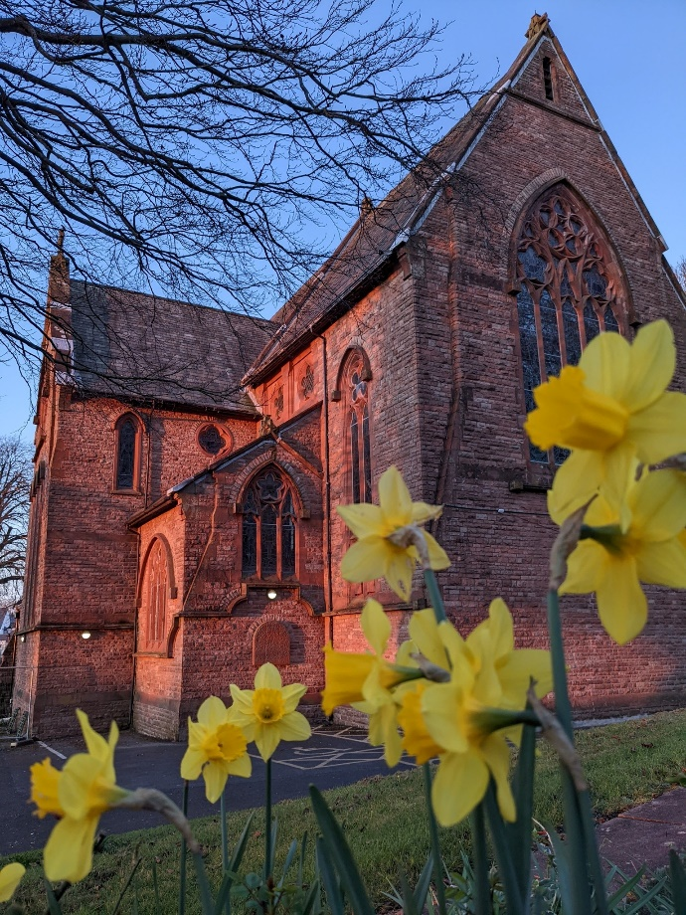
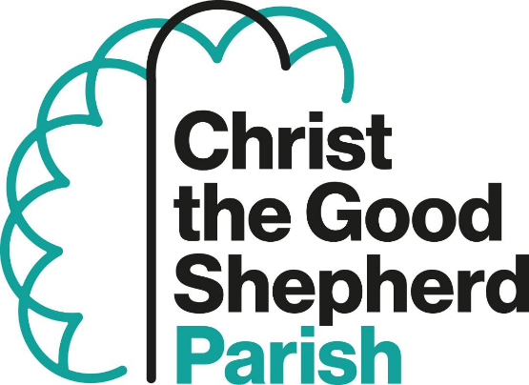
Workington, Cumbria
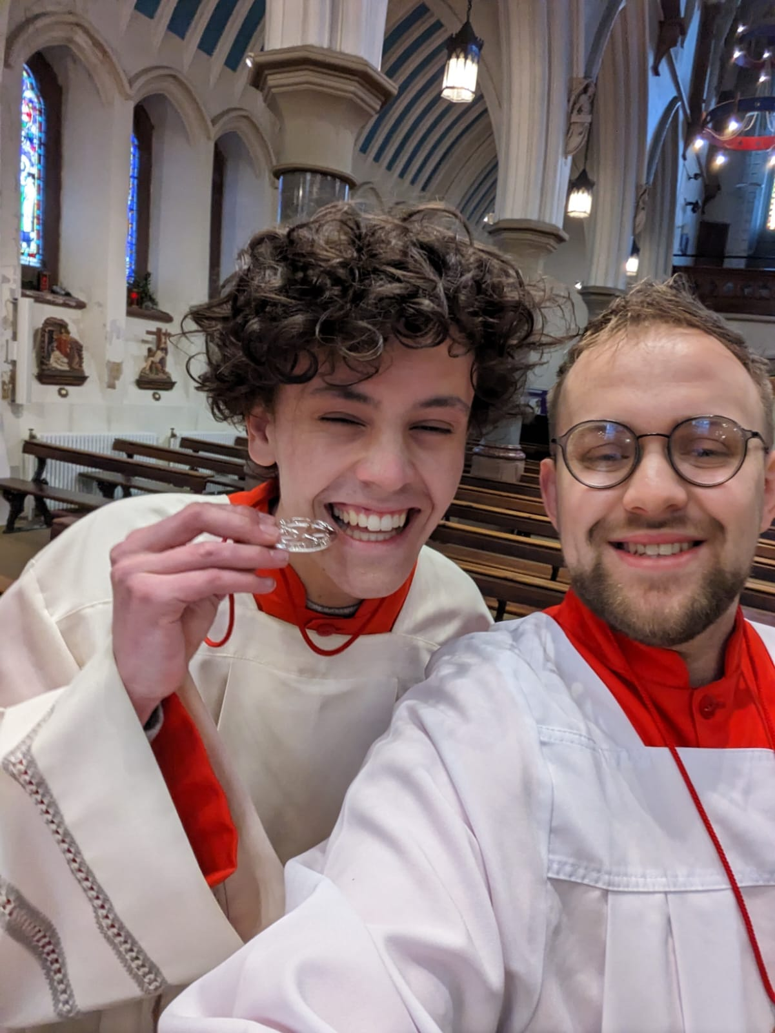
ALTAR SERVERS

In the Parish of Christ the Good Shepherd, Workington, we are blessed to have 40 Altar Servers in the parish team across all age ranges.
There is a vocational character to the work we do. Serving becomes more than just turning up on a Sunday every week or once in a while and supporting the big parish occasions. It is a ministry to which each one has been called and each has had the courage to respond. The parish rises up by supporting and encouraging them.
Servers have an environment to grow in their awareness of why they have been personally called to serve the Lord at the Altar. Yes, it is important they look smart, pray before Mass to prepare themselves, attend training workshops and learn what, how and why they do what they do… but it’s about nurturing a ‘holy’ curiosity.
It is wonderful to see those who have taken on other roles in the parish, or continued serving while at university or gone onto chaplaincy work. We have some who went on an Easter Triduum retreat to deepen their faith and make new friends. We have those who joined the diocese in Lourdes this last year and met other servers along the way. Then it was World Youth Day in Lisbon and two servers went and shared their experiences with the parish.
There is a social dimension to this journey and having fun. Football matches after Mass most Sundays, Team building activities in the summer and away days like a day pilgrimage in the footsteps of St Bega starting out in St Bees Priory then for Ice cream, a cliff top walk finishing with a race on the secluded pebbled dashed beach of Fleswick bay with time for quiet reflection and prayer. We also plan to have a five-week course ‘Altaration’ The Mystery of the Mass revealed and so enter deeper into the mystery of the Mass.
The Archconfraternity of St Stephen, to which they are enrolled, plays its part in recognising their commitment and their promise to offer themselves, to do their best, to serve with reverence and understanding, all for the glory of God, the service of his Church and their own eternal salvation.
St Stephen, Pray for us. Paul Briers
Lancaster Diocesan guild dinner

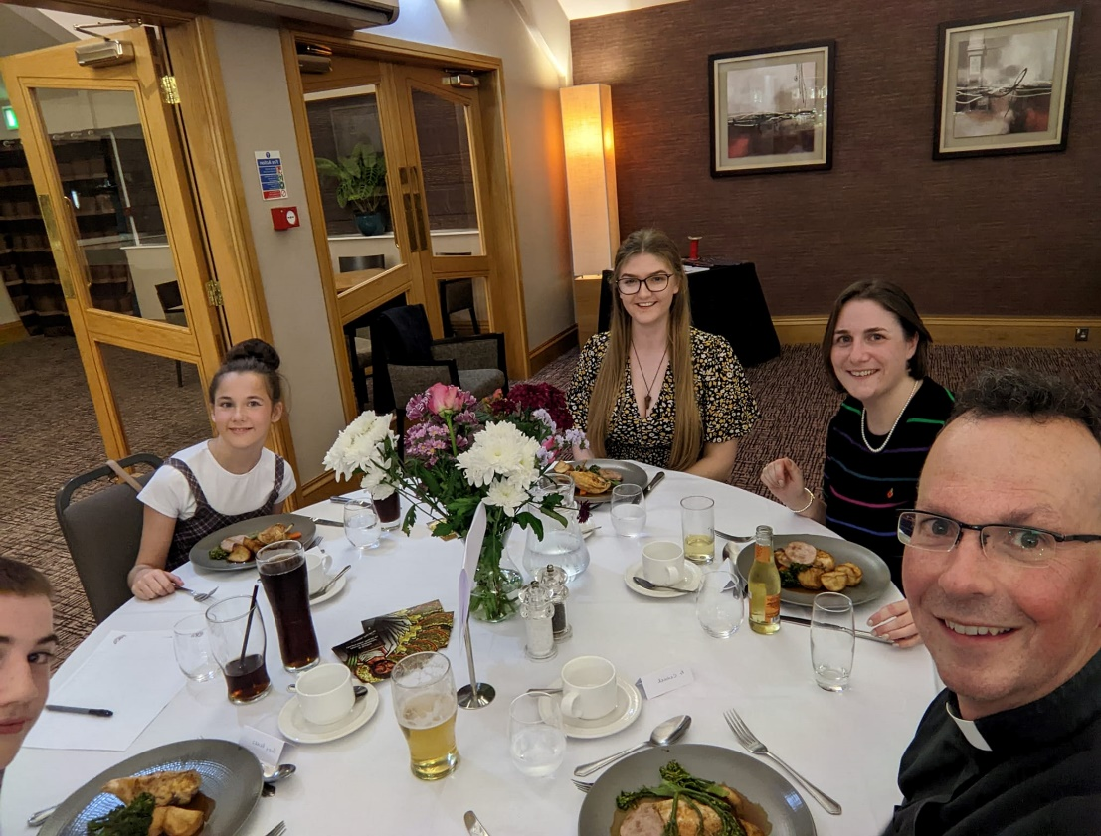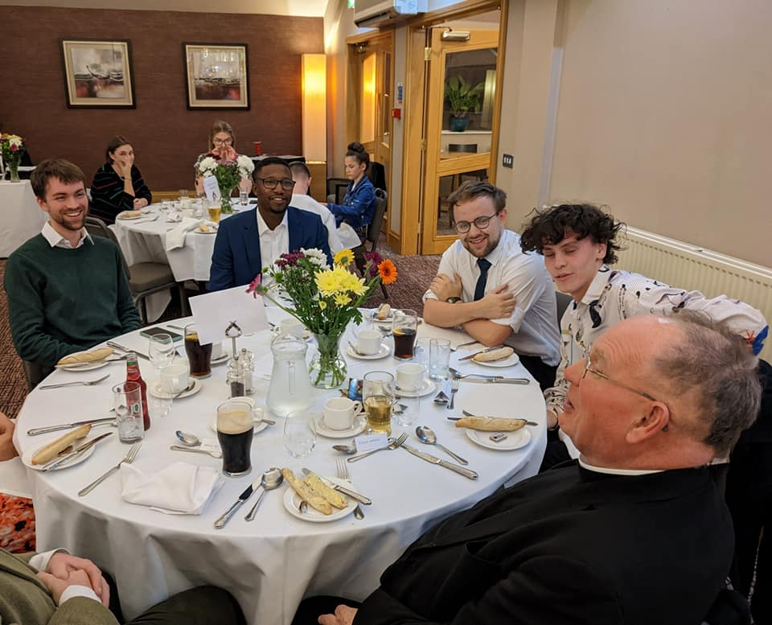

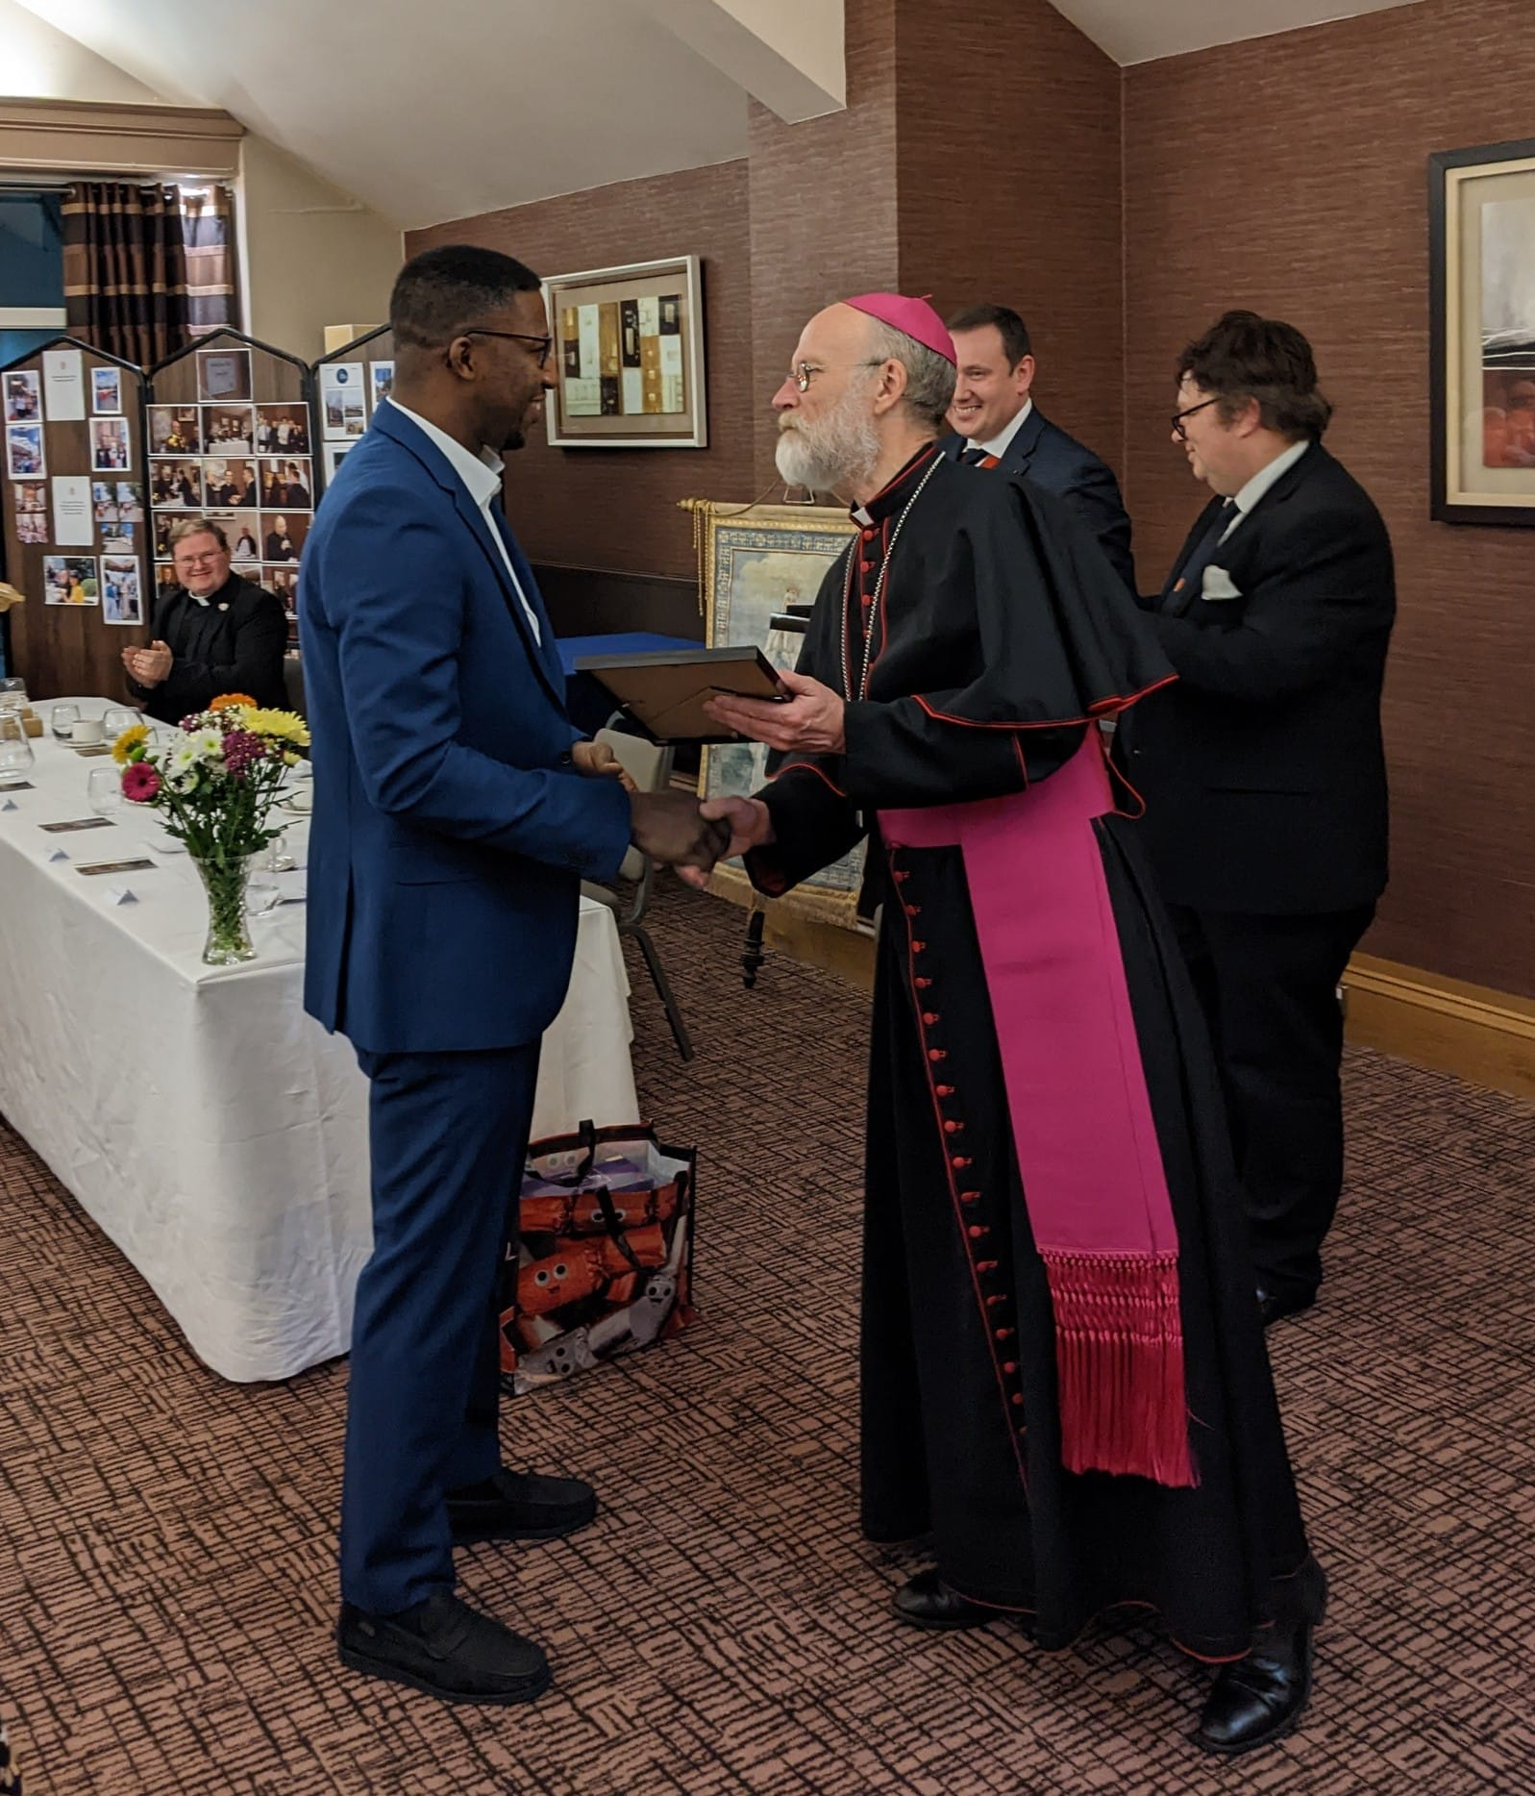
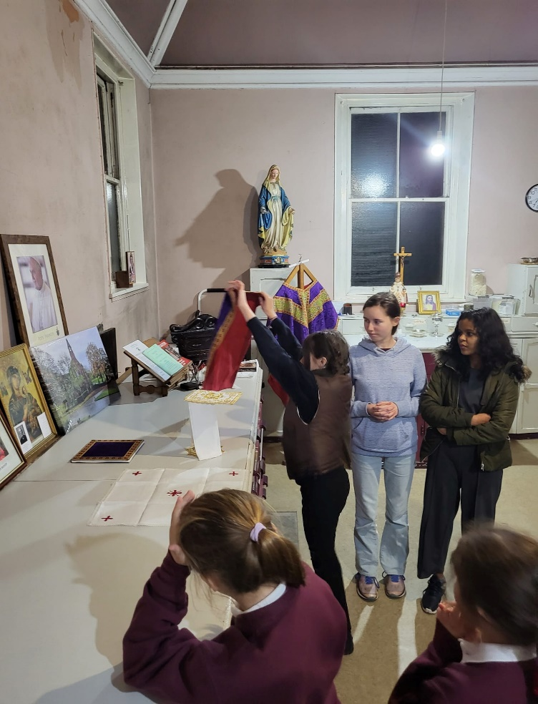
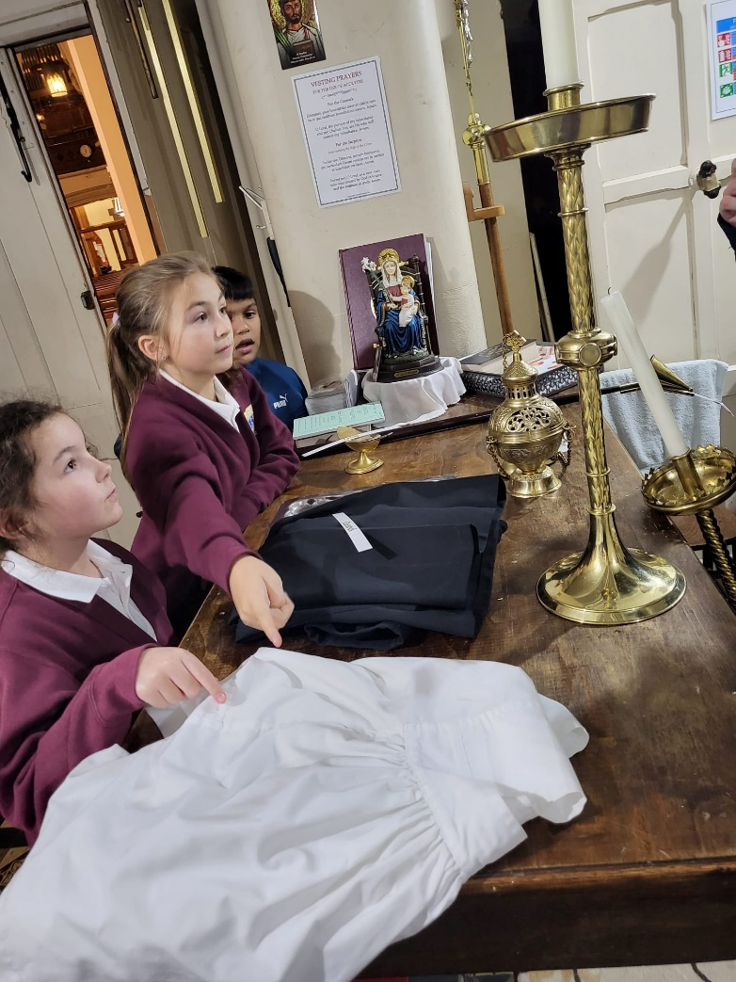
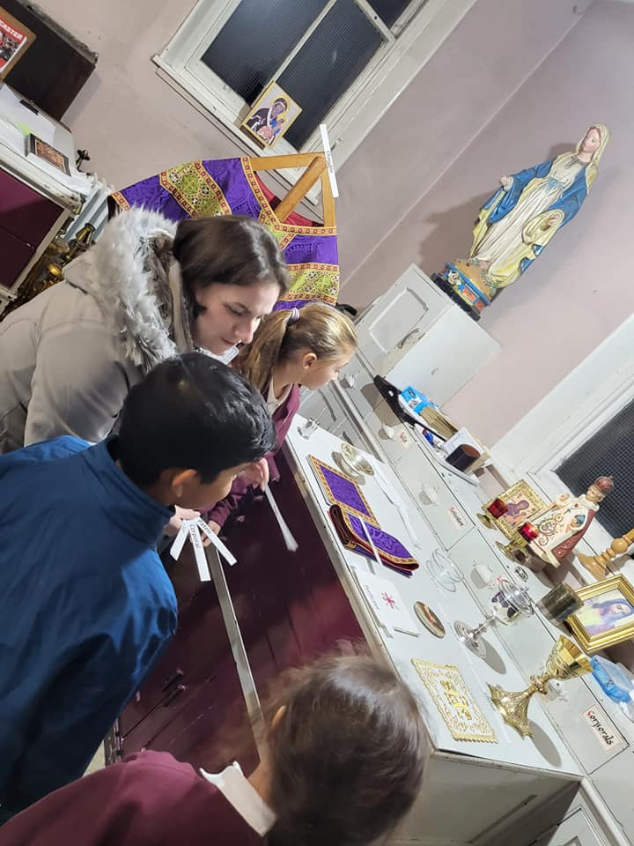
Training nights for younger servers 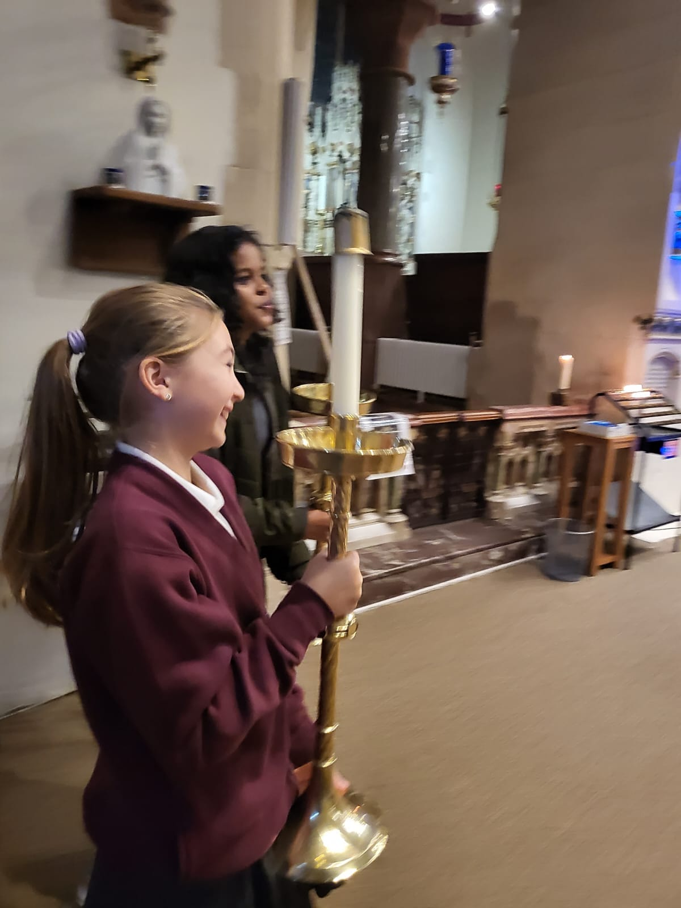 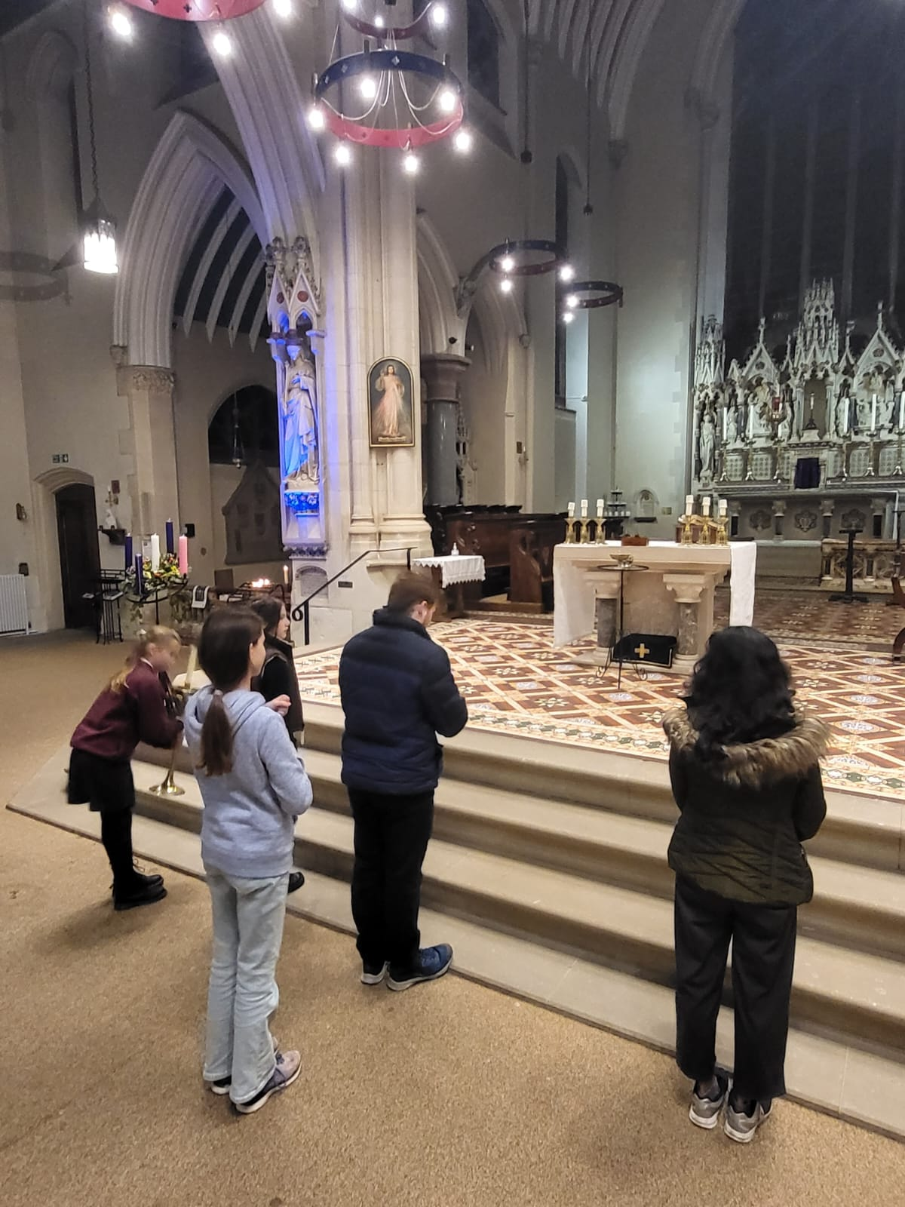 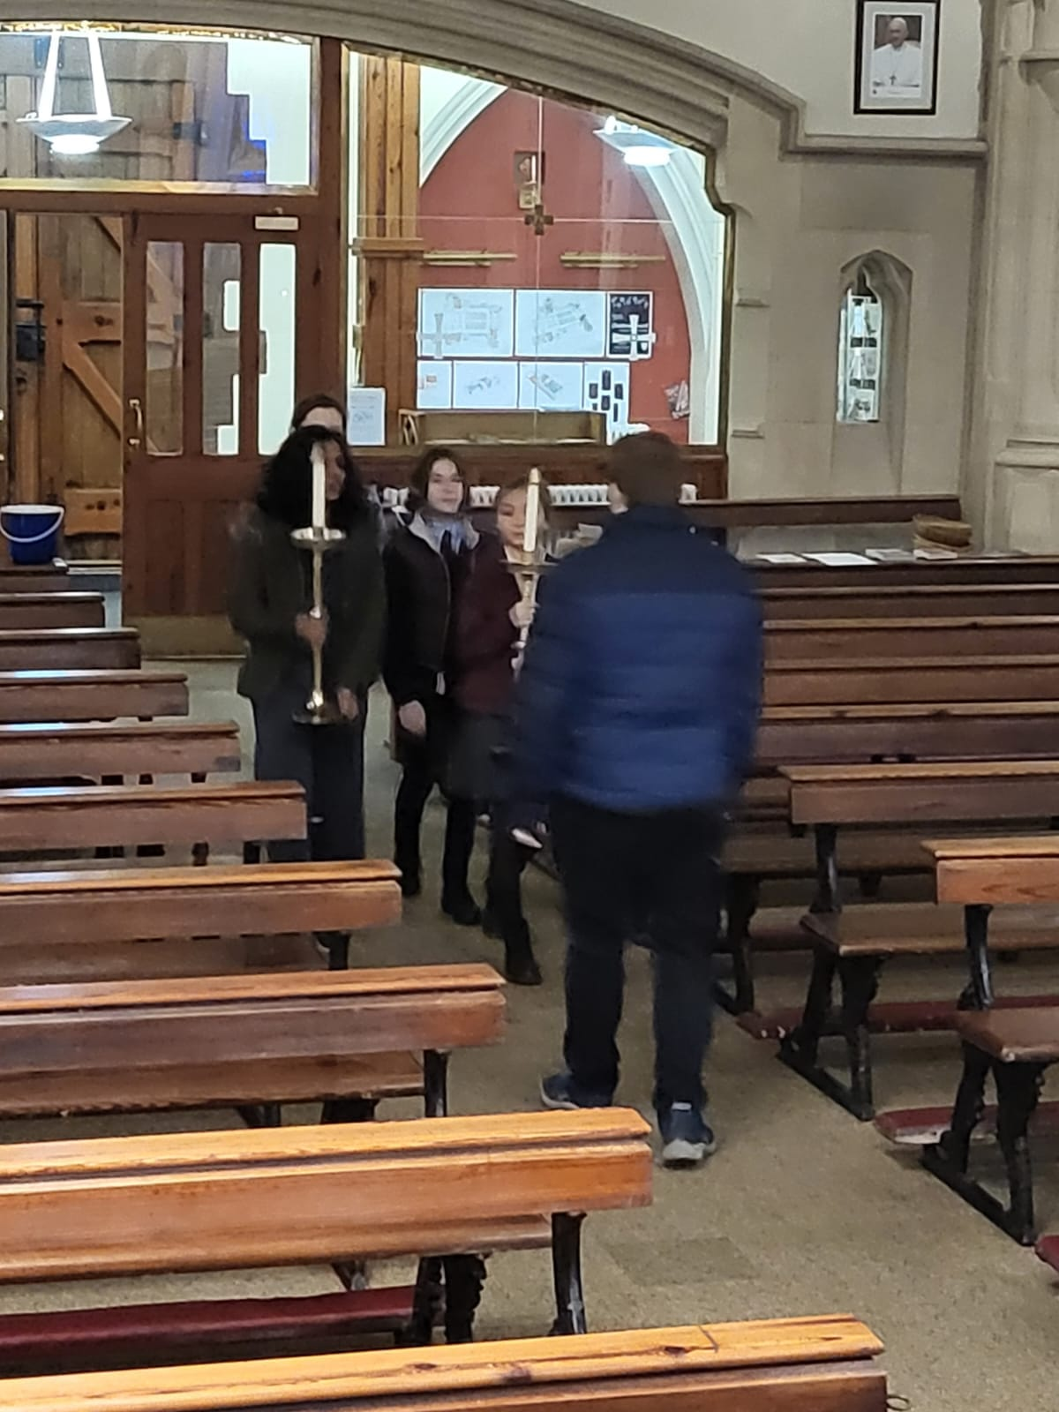 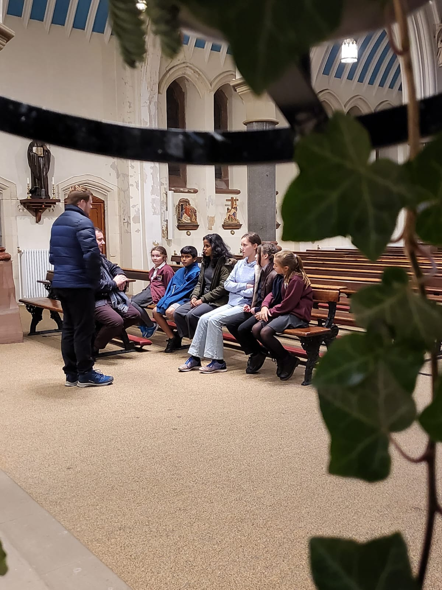

Starting them young….
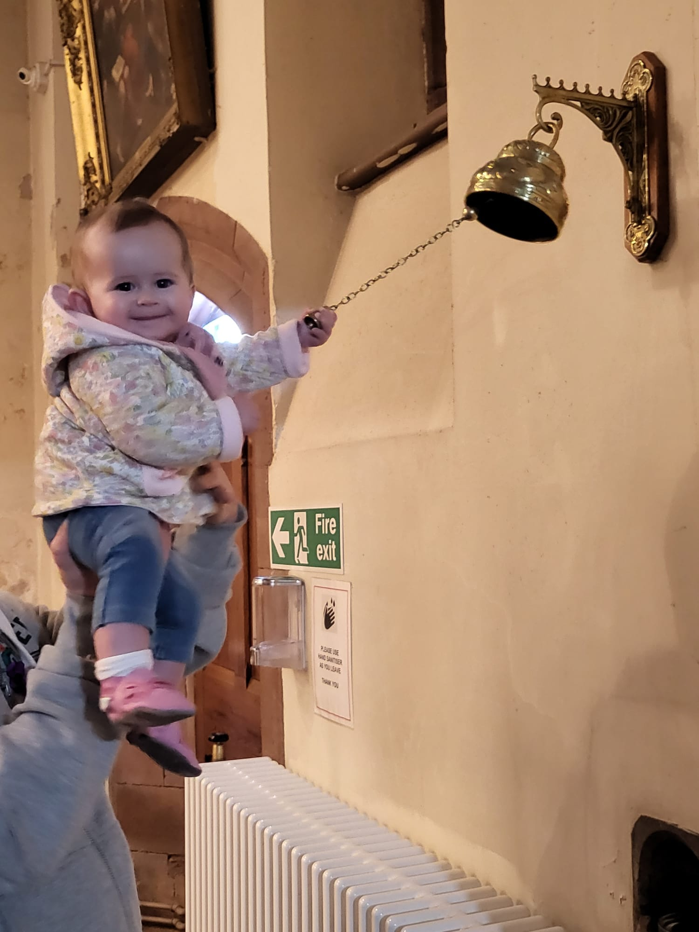

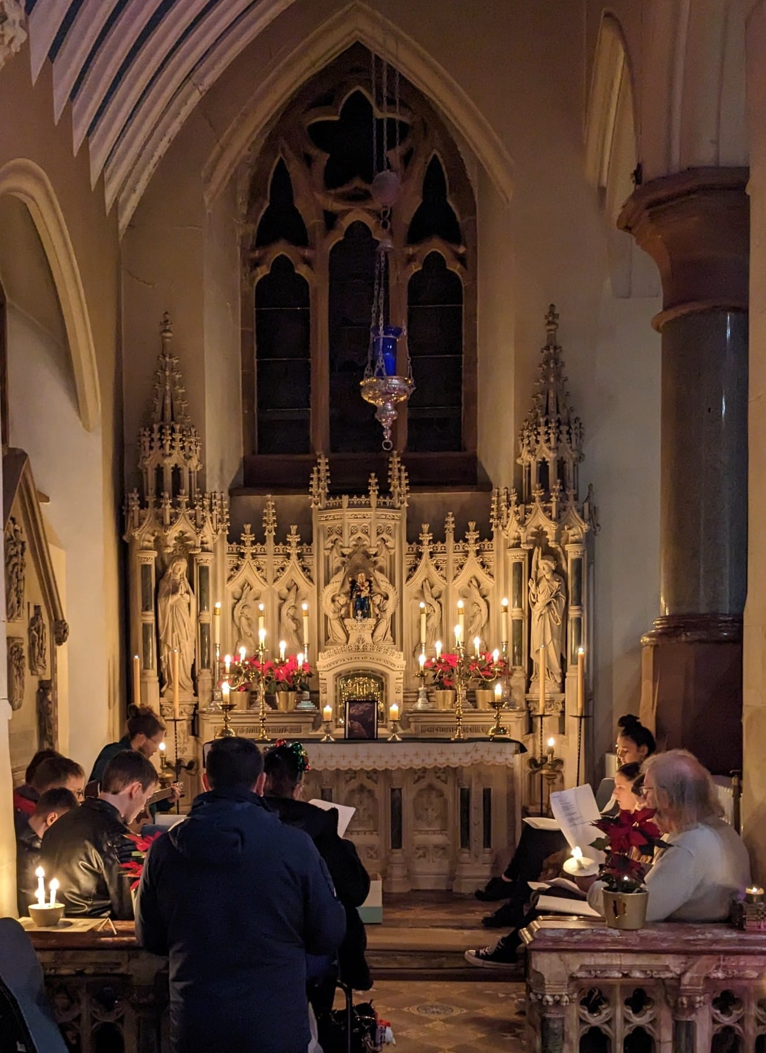
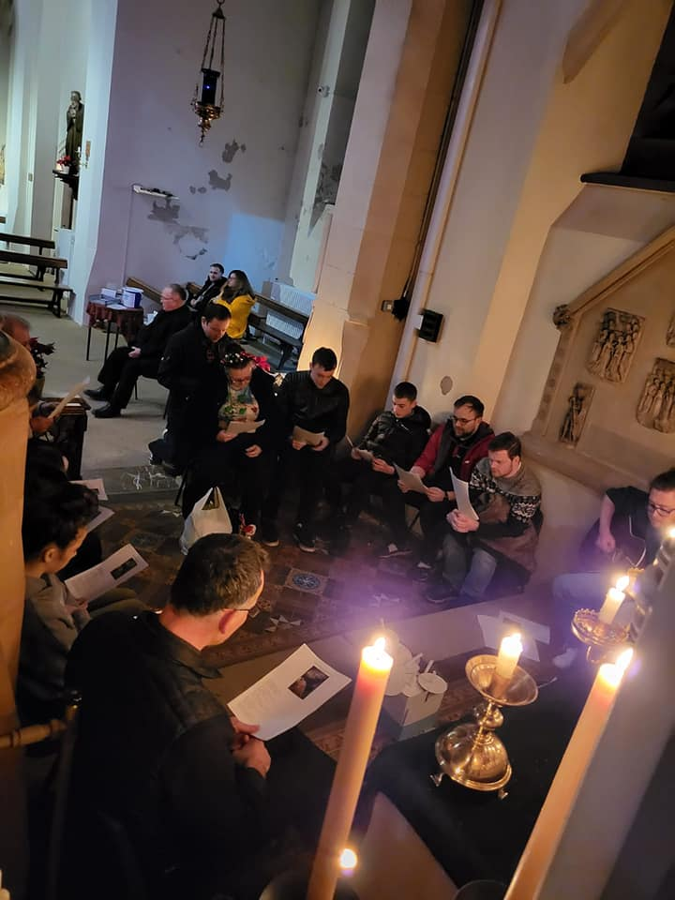
PRAYER AND PIZZA Night

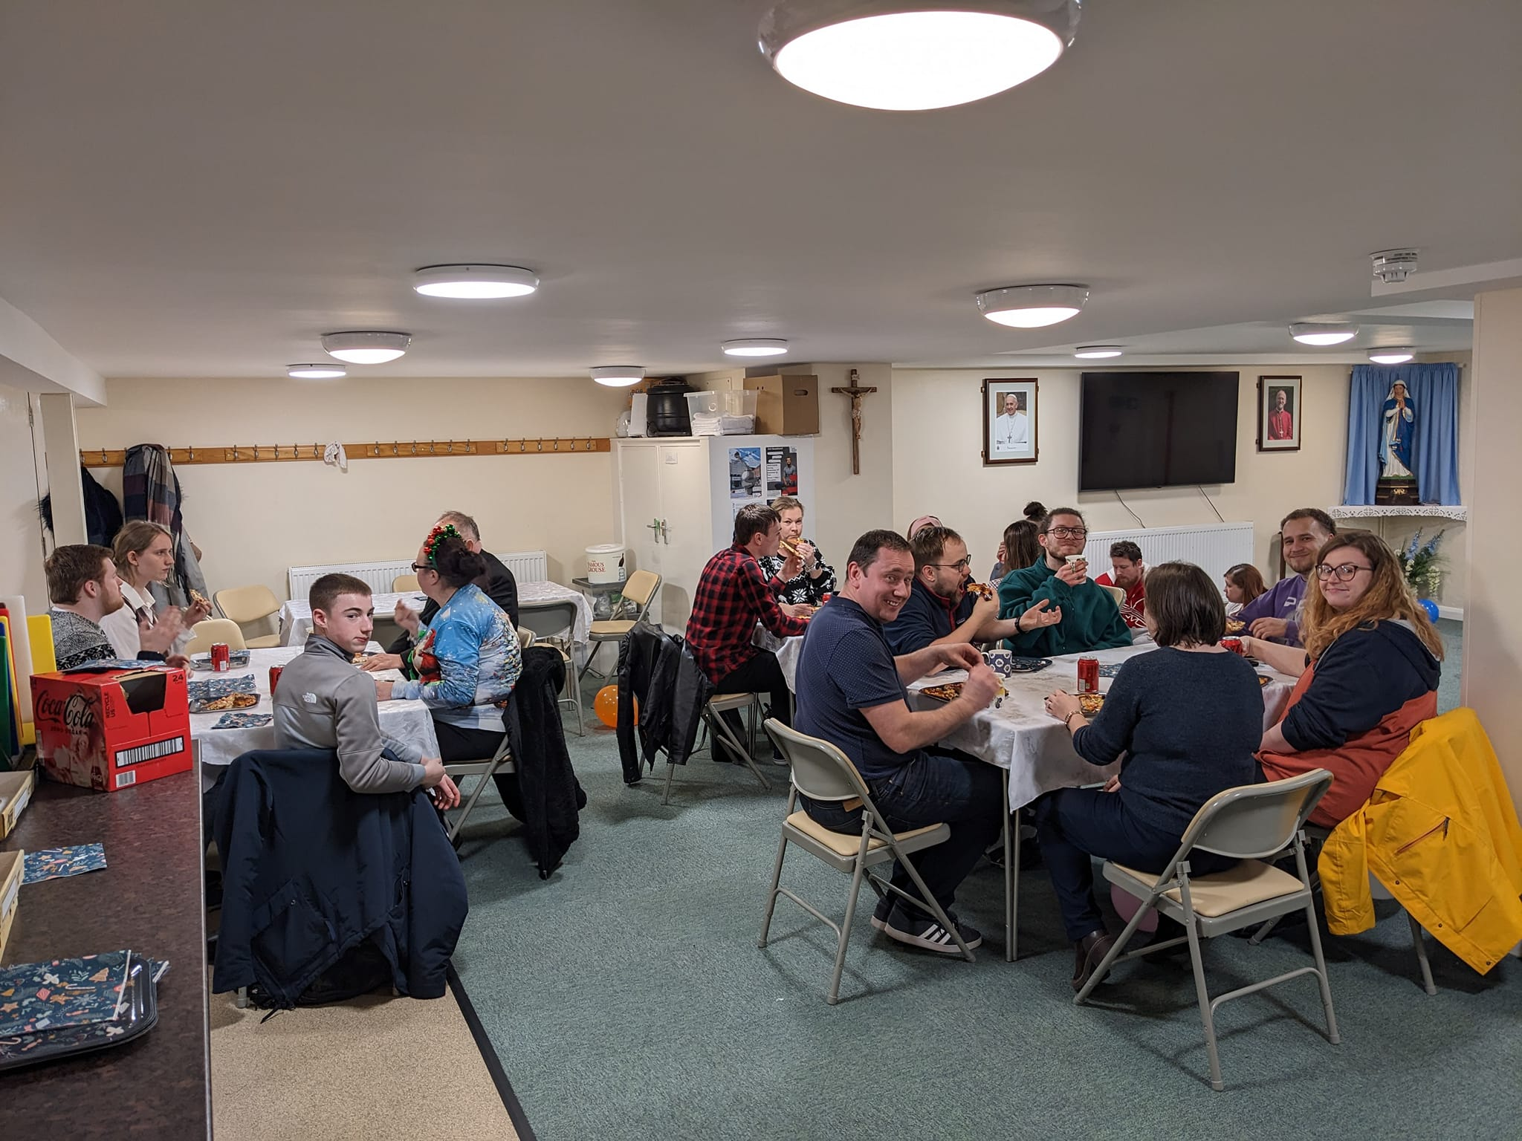

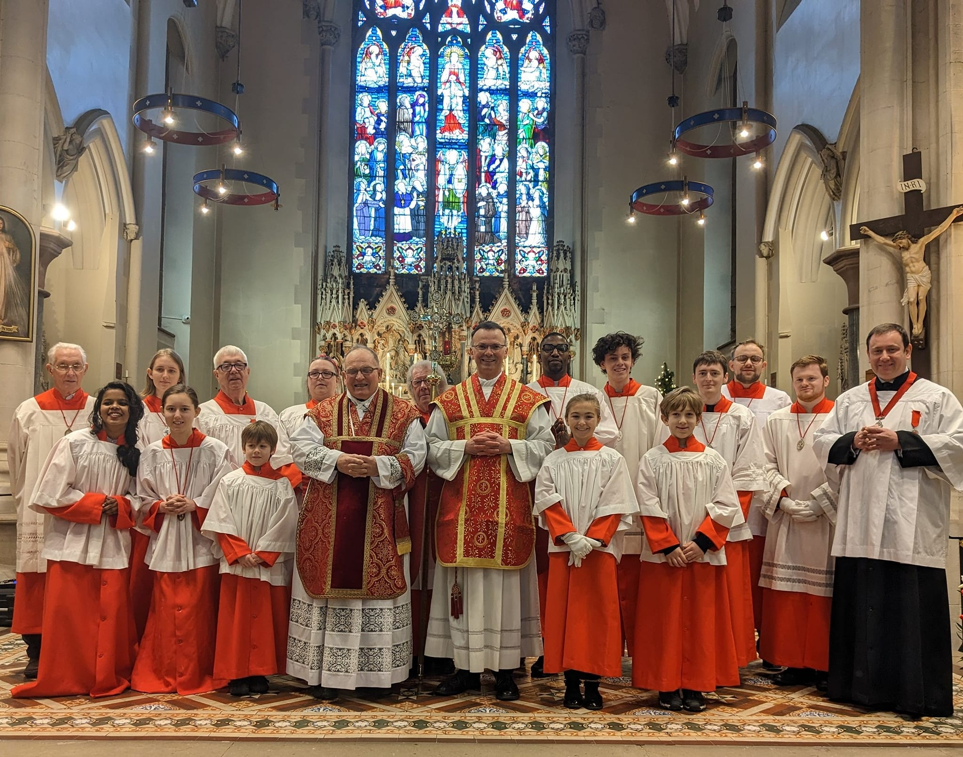
ST STEPHENS DAY

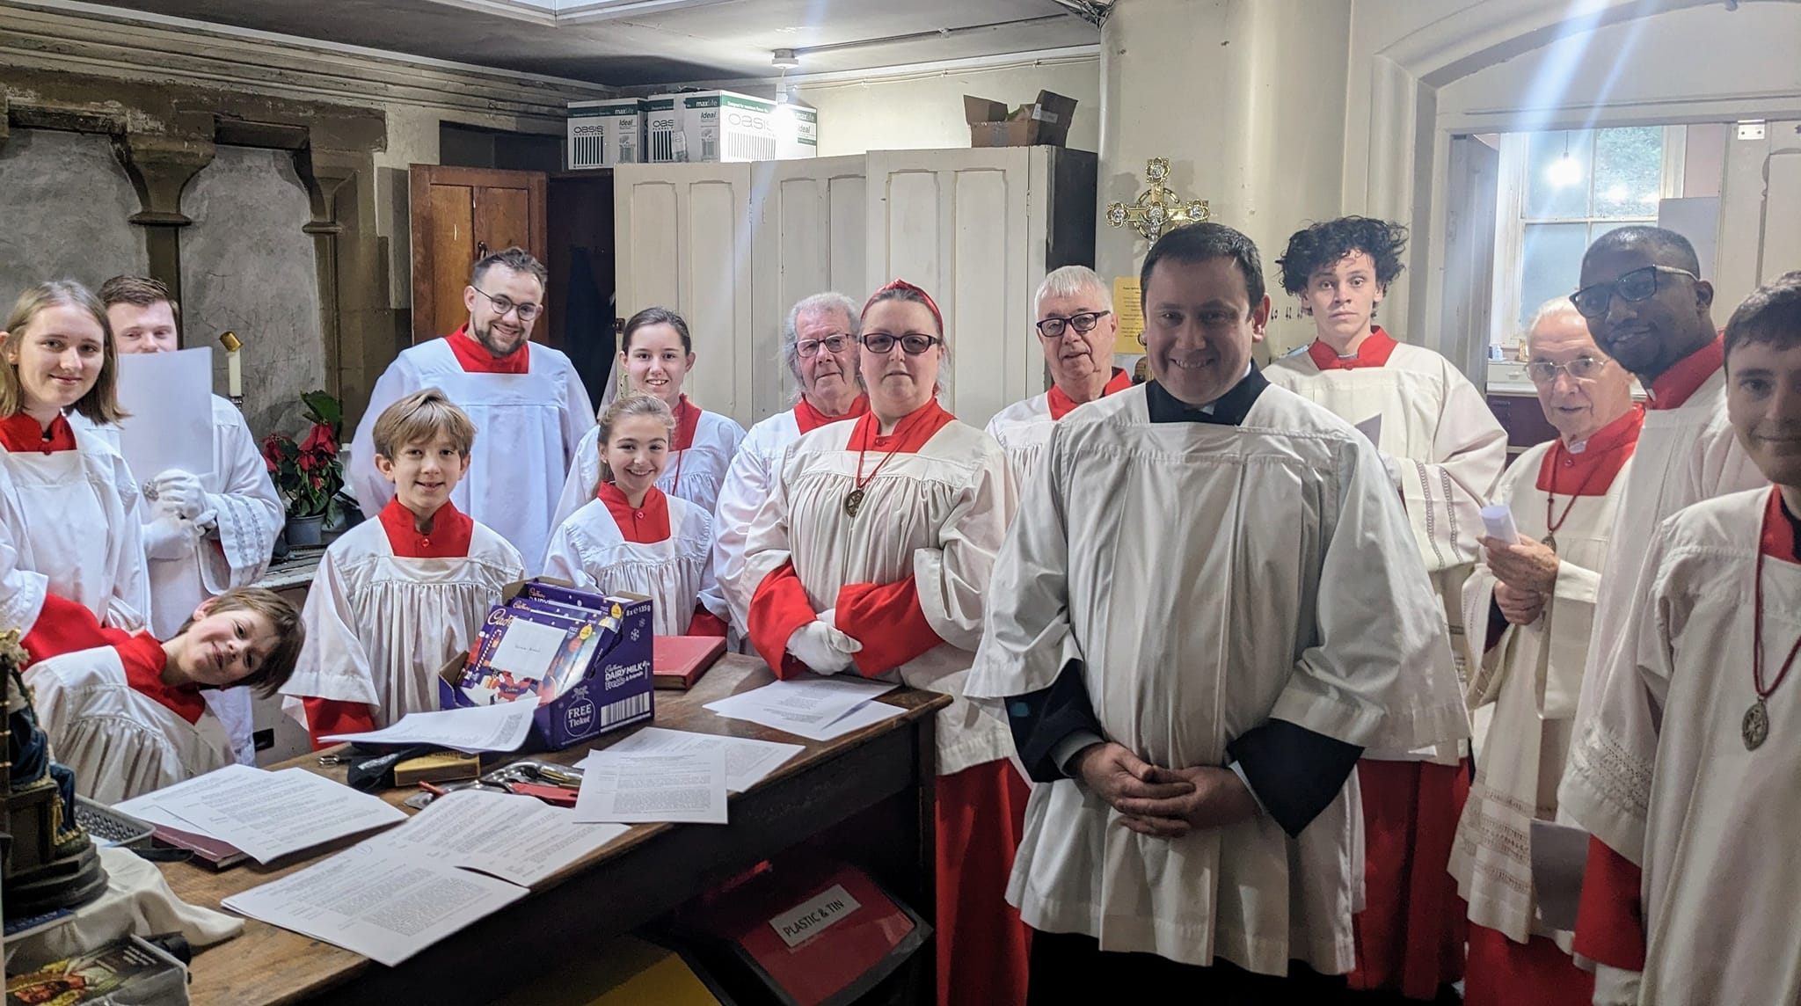

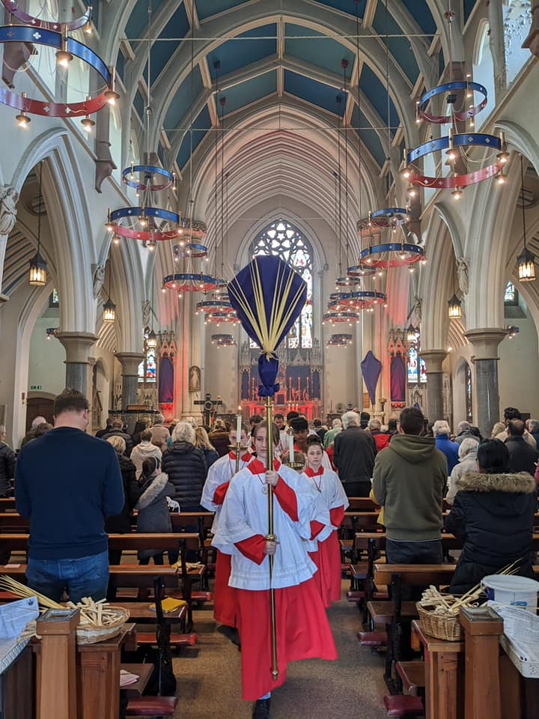
EaSTER

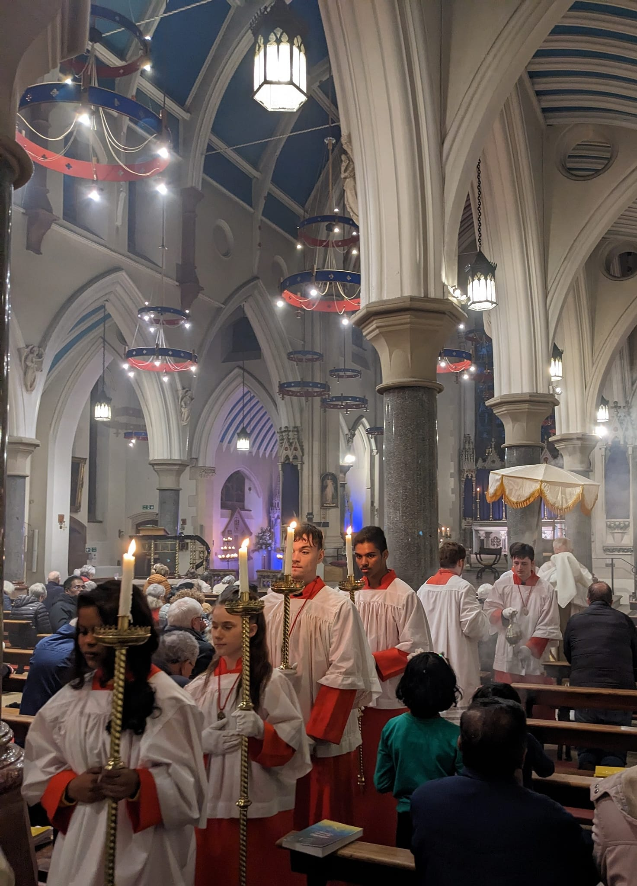

some servers were ON easter RETREAT
AT local Diocesan youth centre

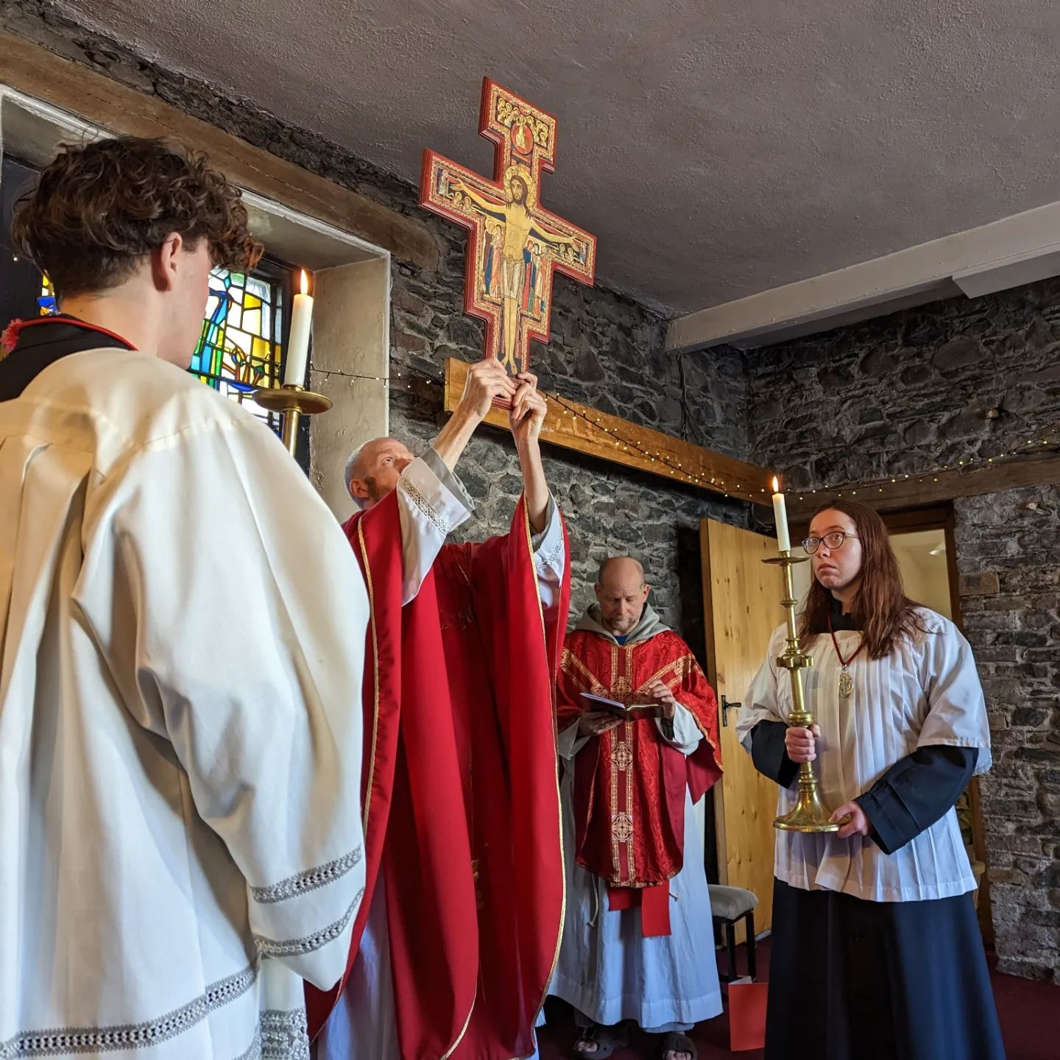

Holy Saturday

8am - Early Morning Breakfast before Rehearsal and preparations.
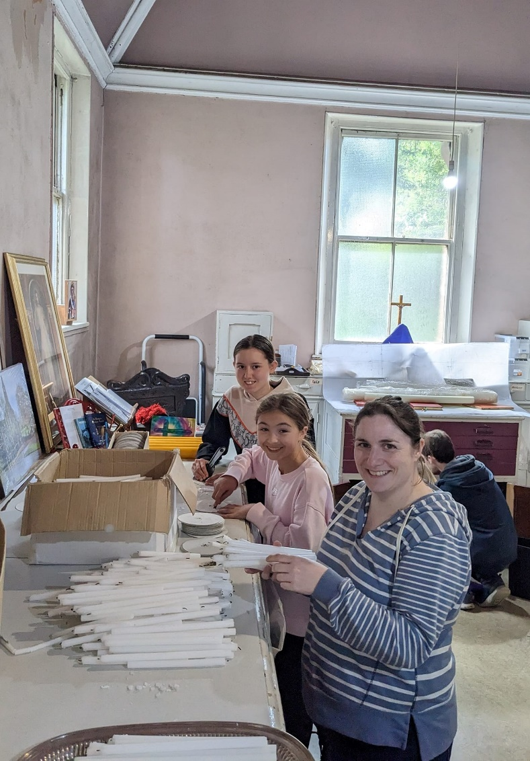
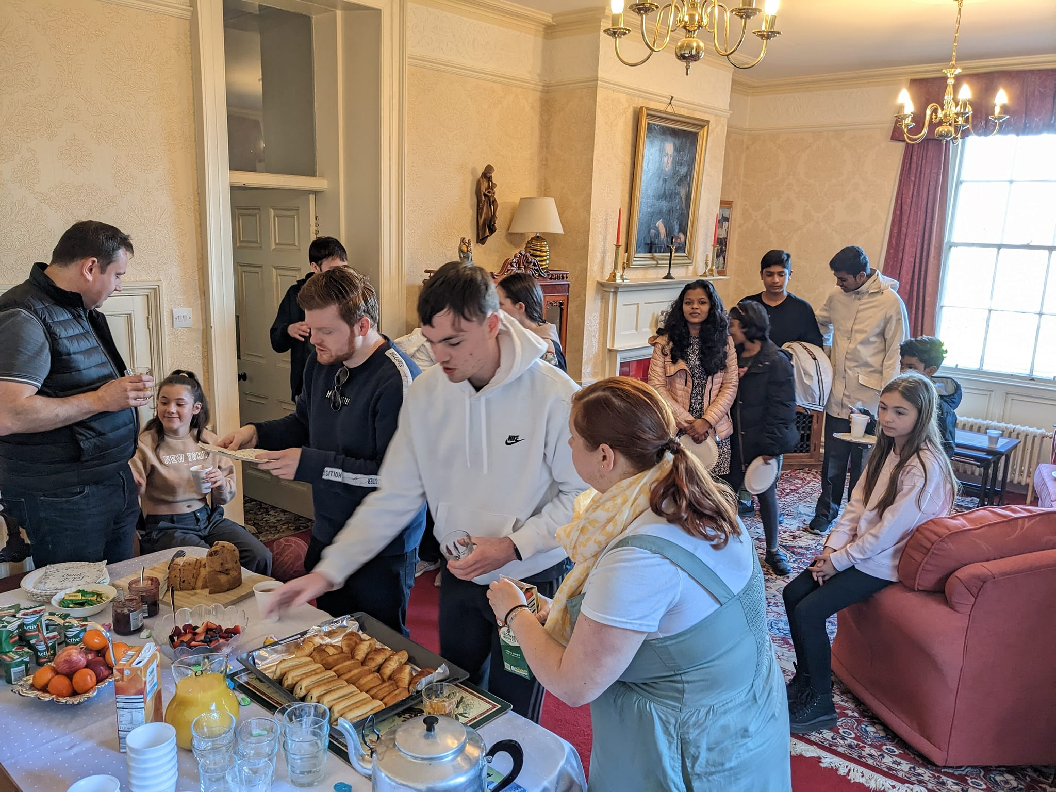
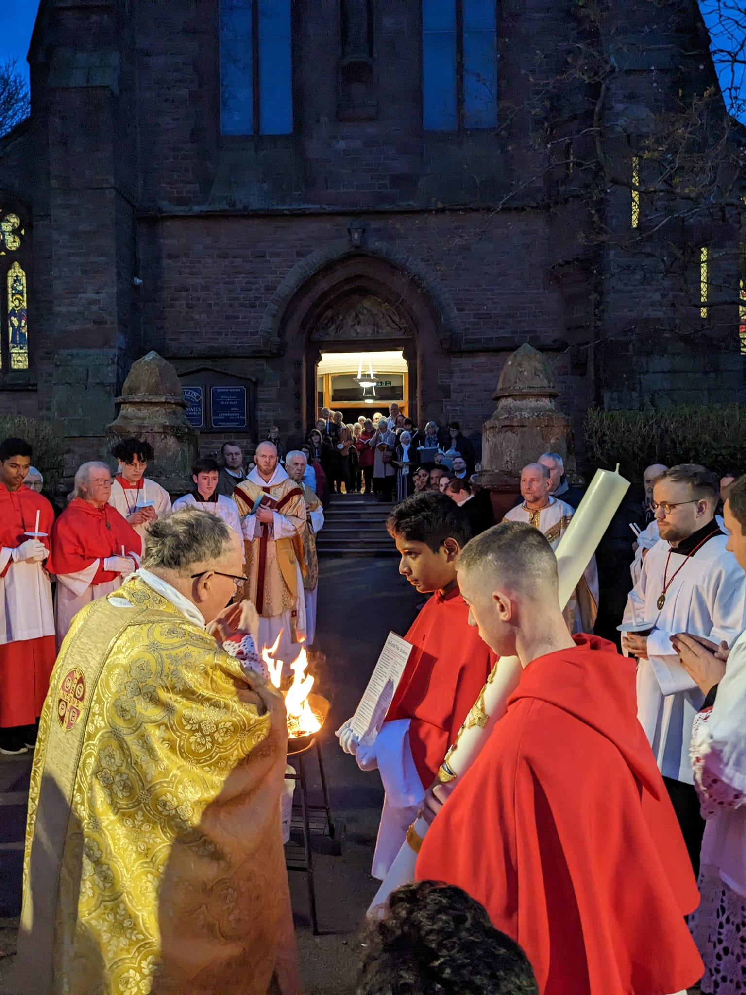
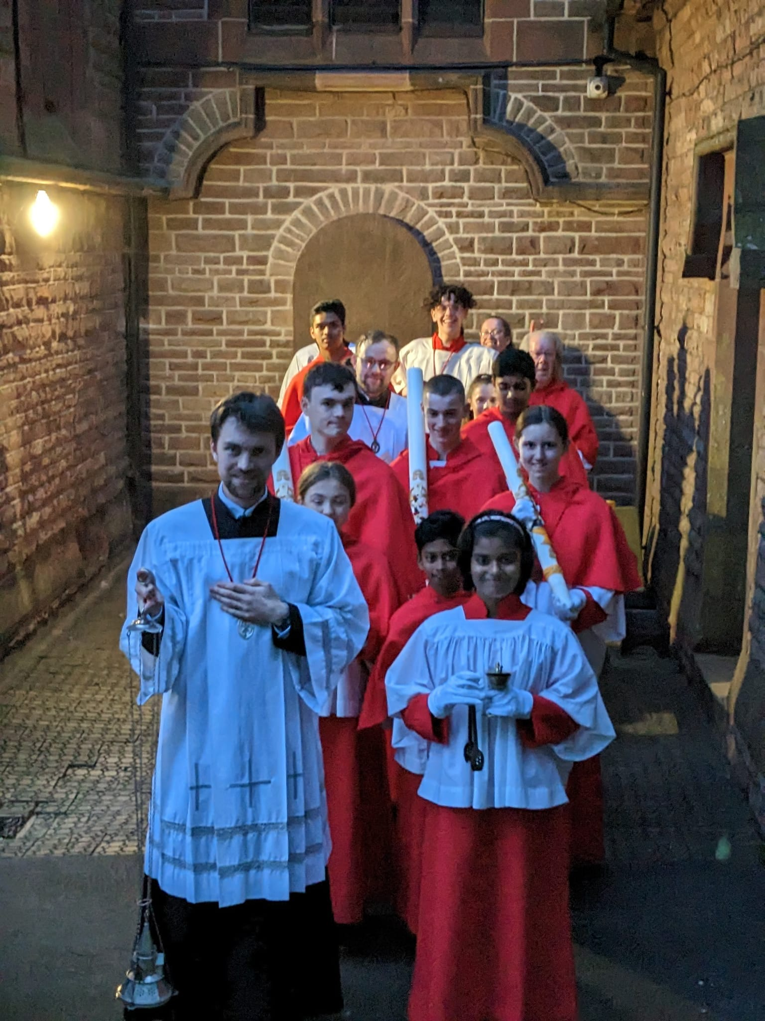

Parish Mission
led by Franciscan friars of the renewal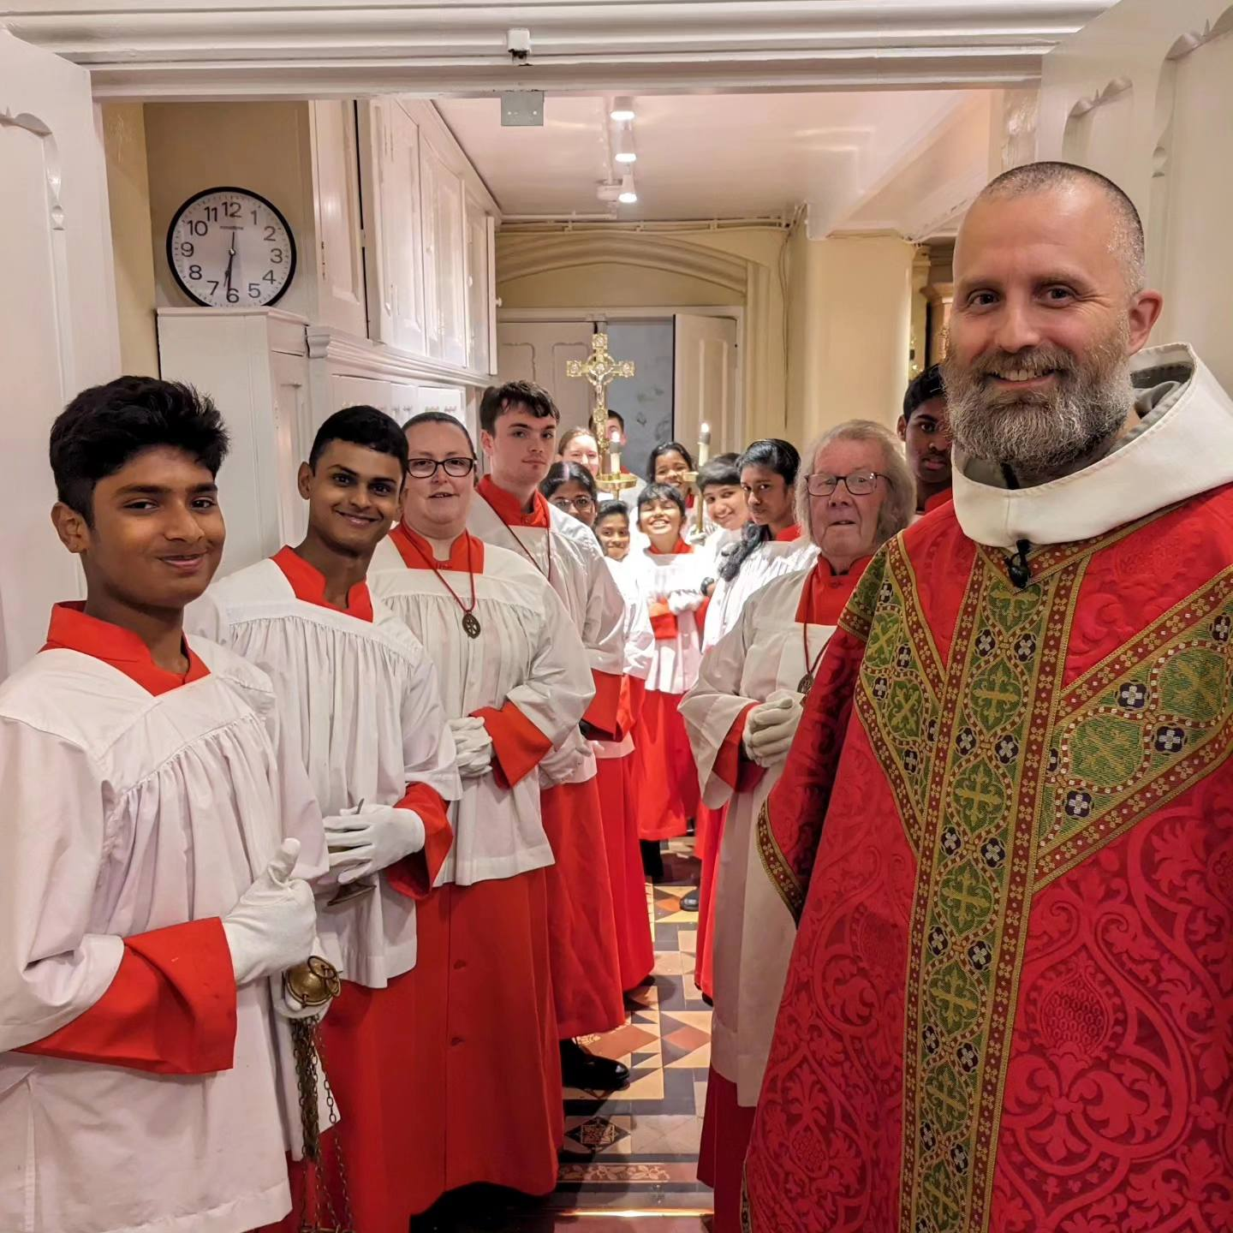
Down time together
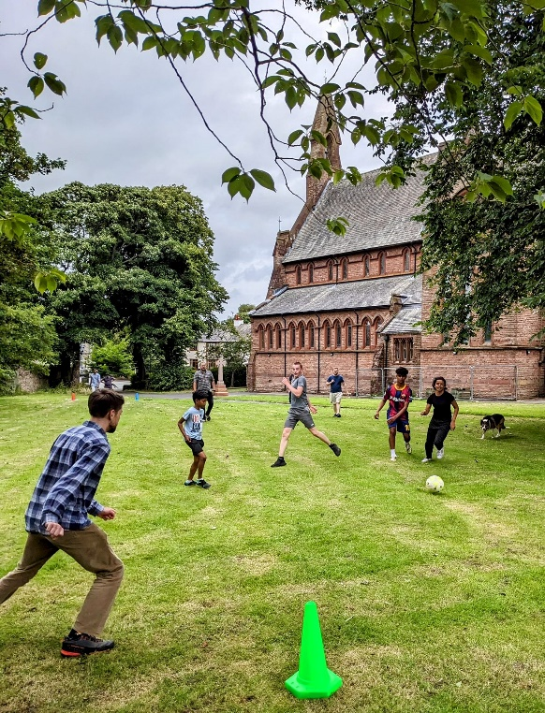
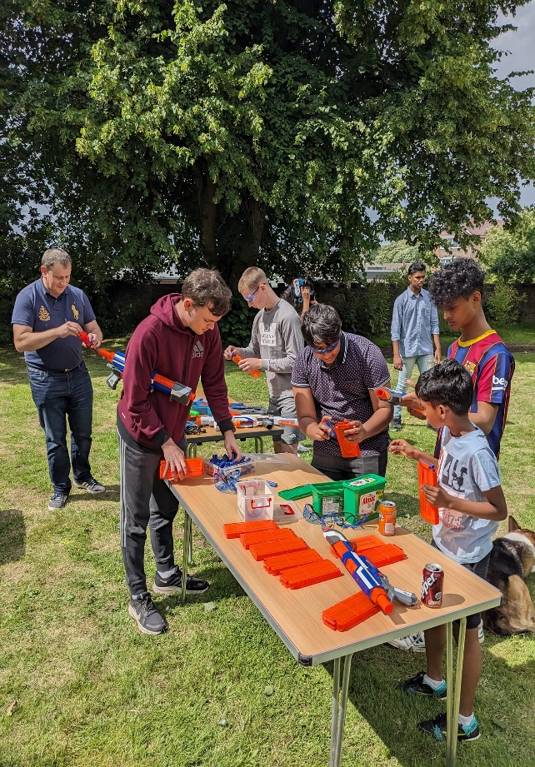

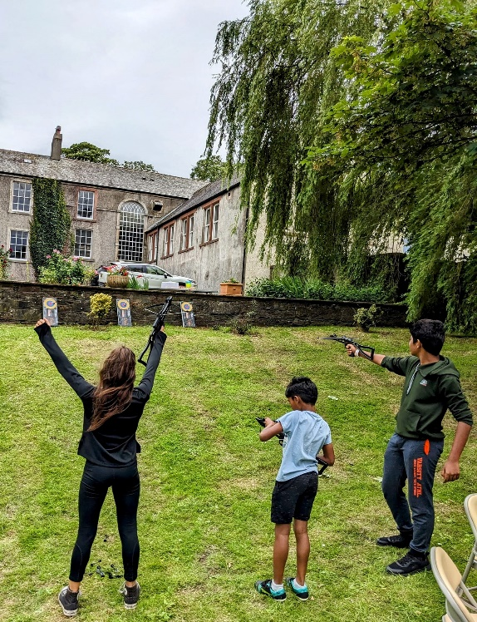

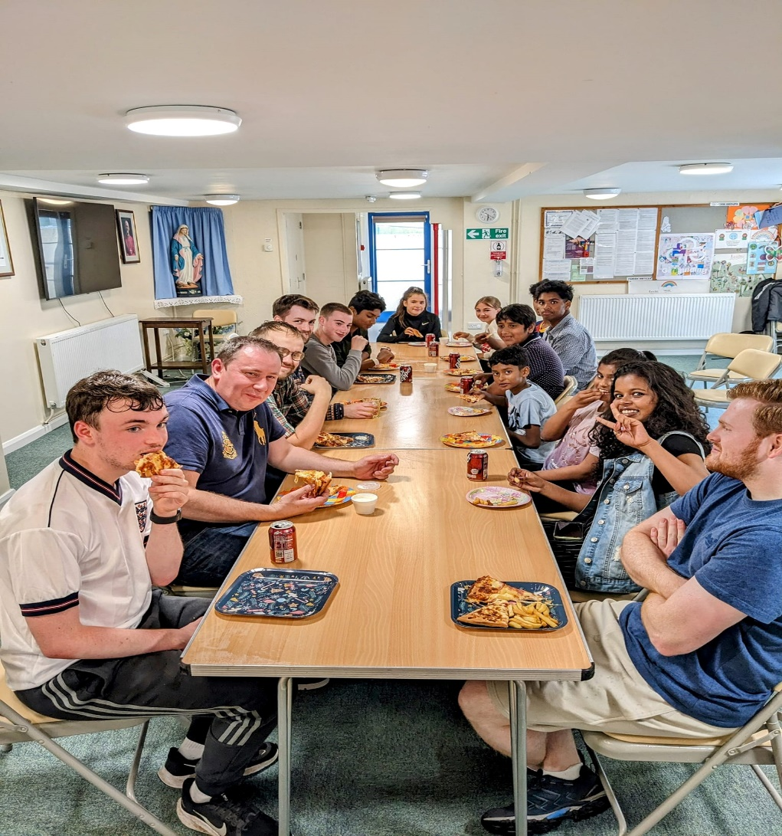
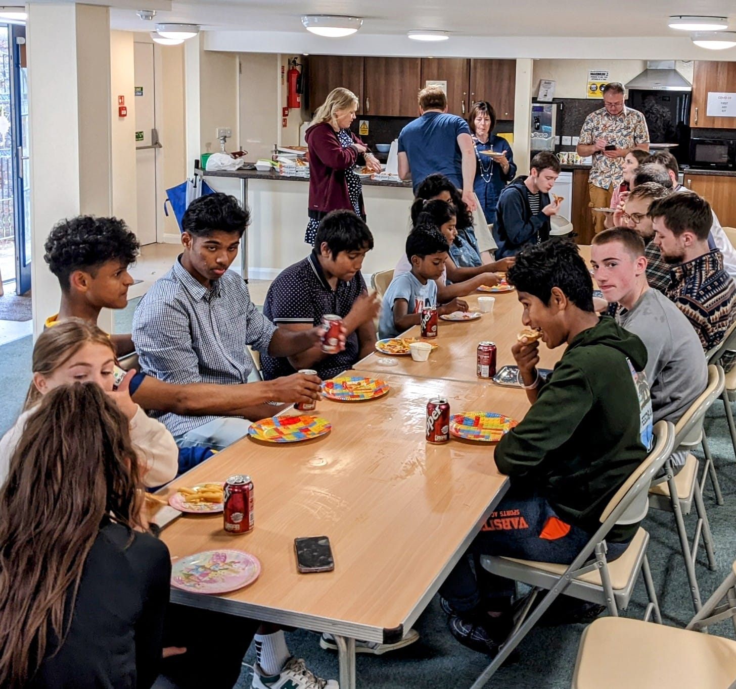

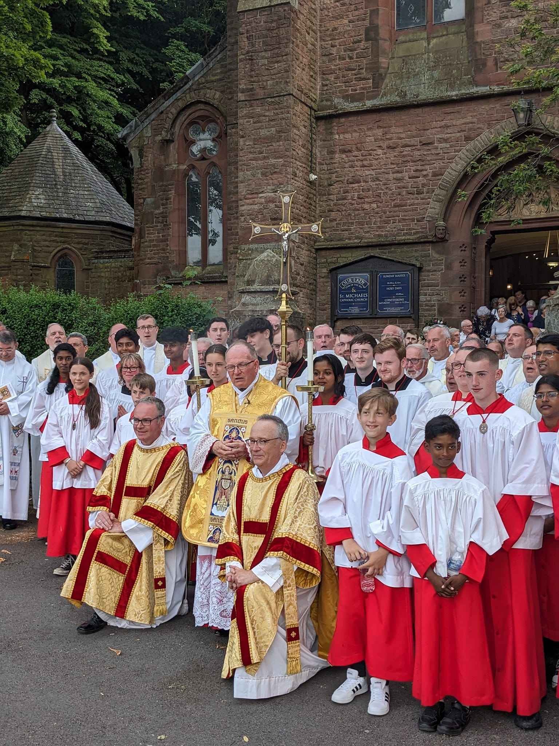
GOLDEN JUBILEE OF Ordination
1 very happy canon,
32 Priests, 2 deacons
and 28 altar servers
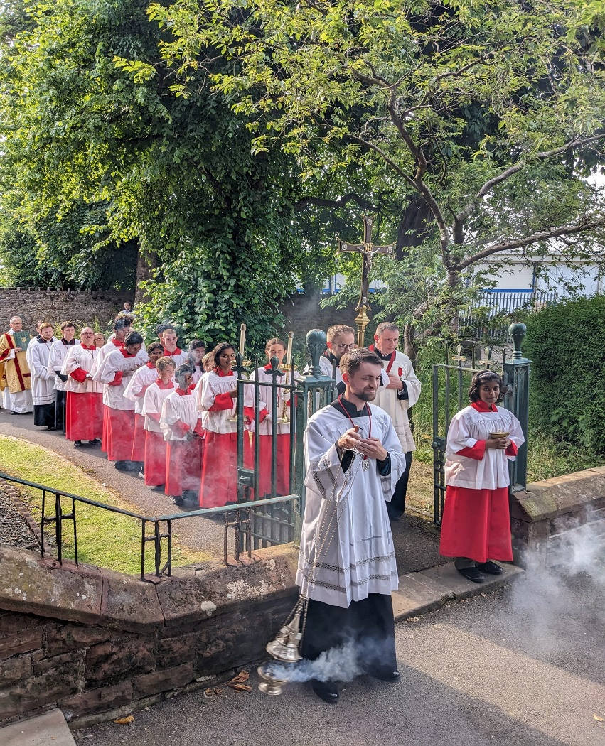

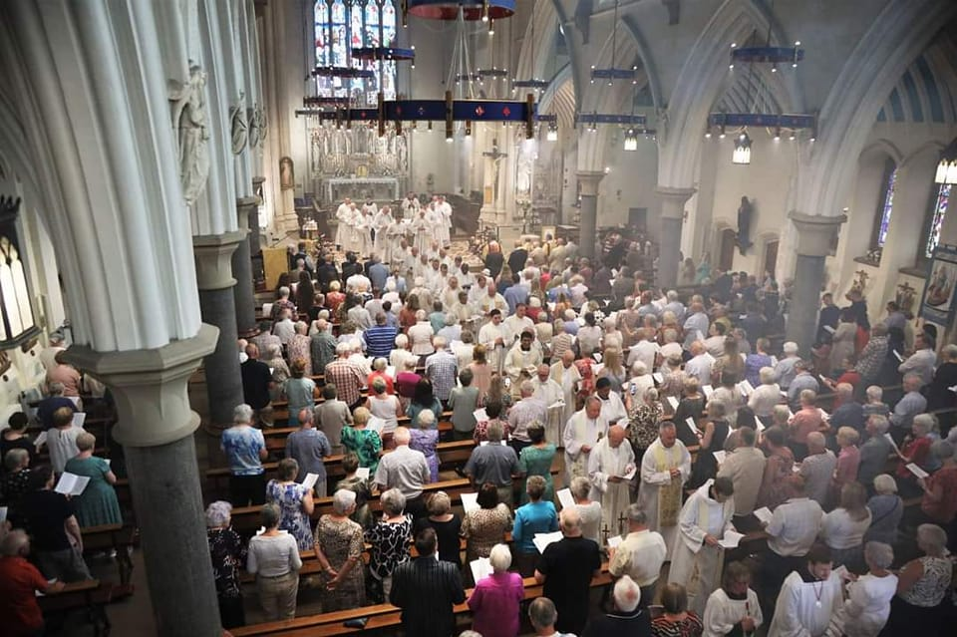

Corpus Christi
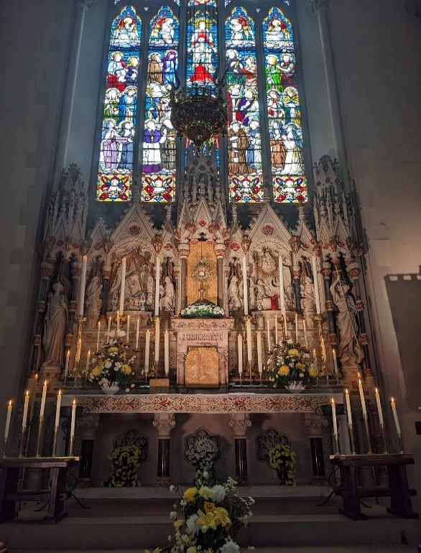
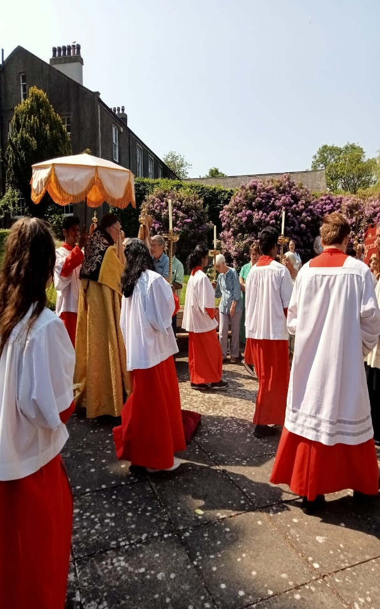
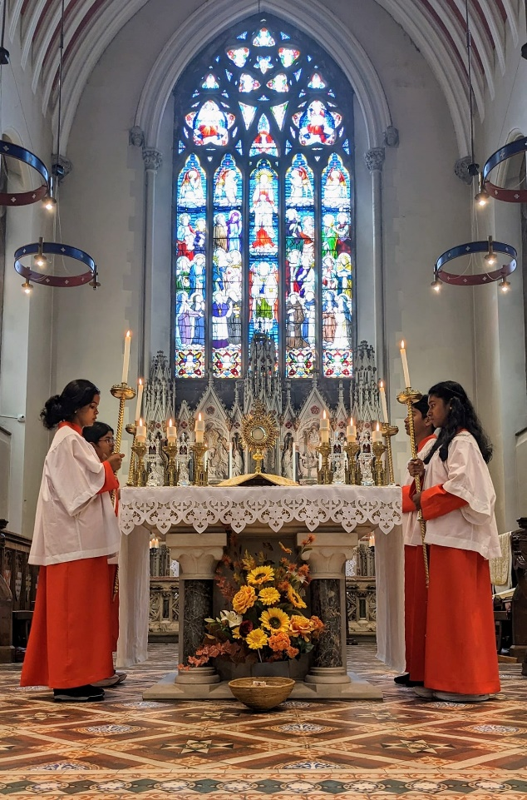
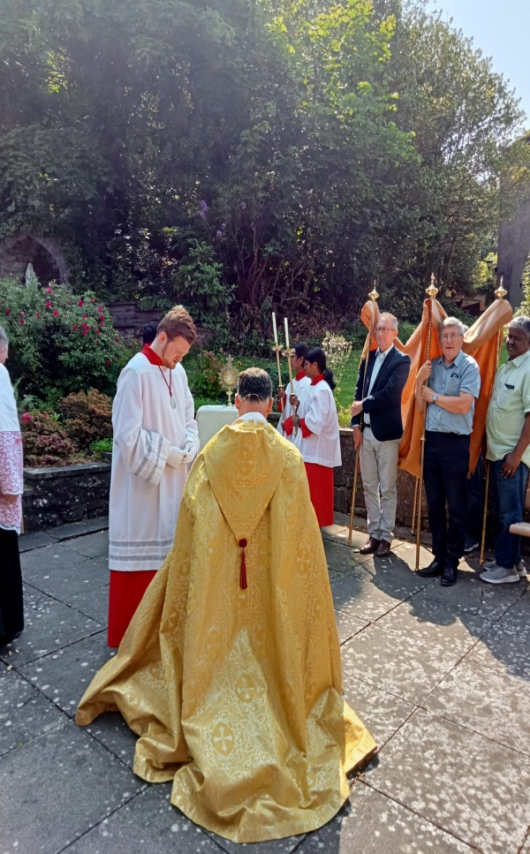

TWO SERVERS off TO WORLD YOUTH DAY – LISBON
pictured with local Catenian Circle. 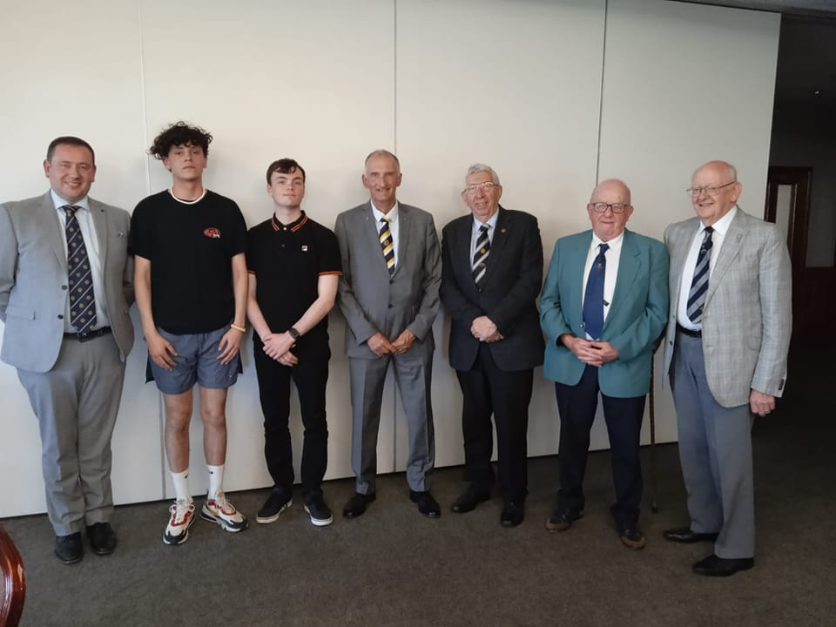

Confirmations by bishop of lancaster
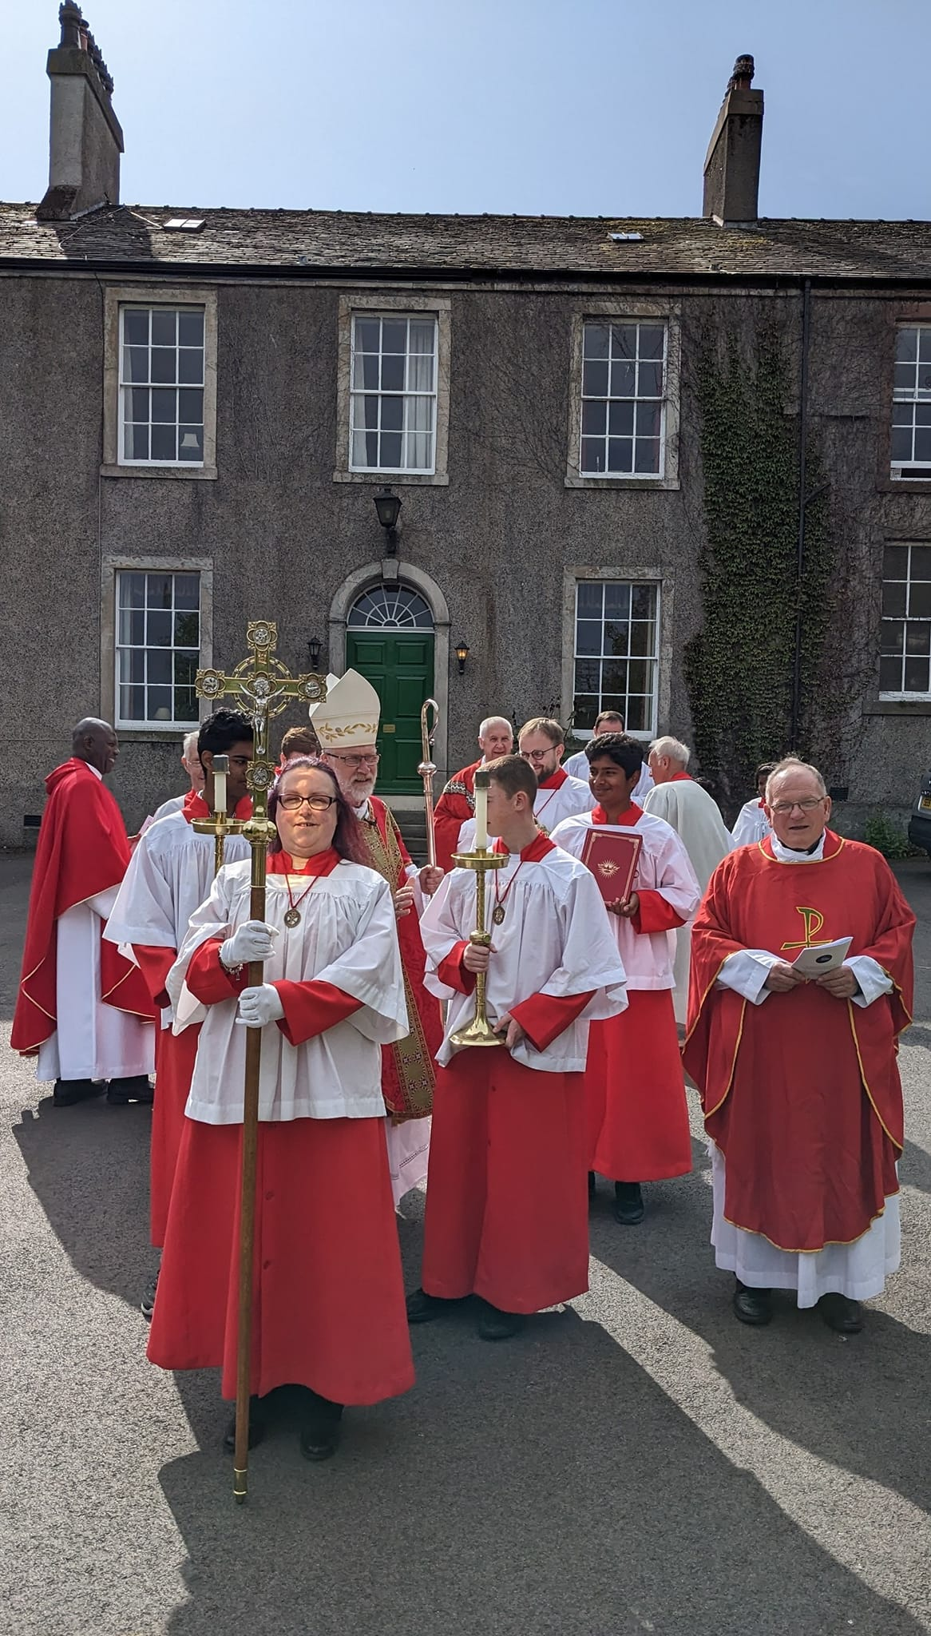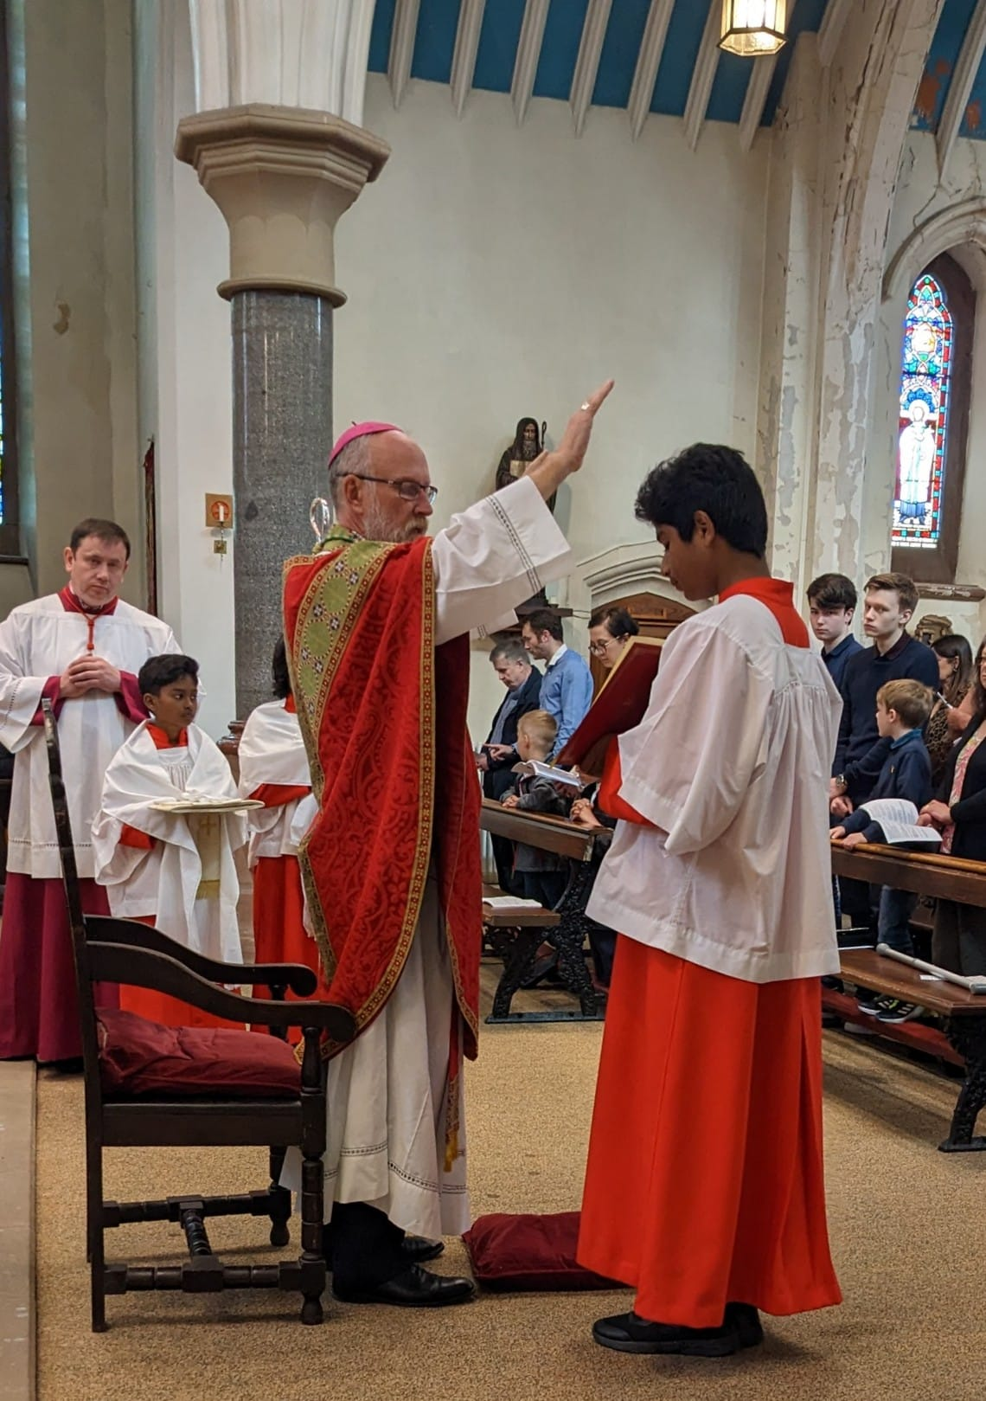
One server becomes Cumberland west
conker champion.
Presentation made by president of local catenian circle
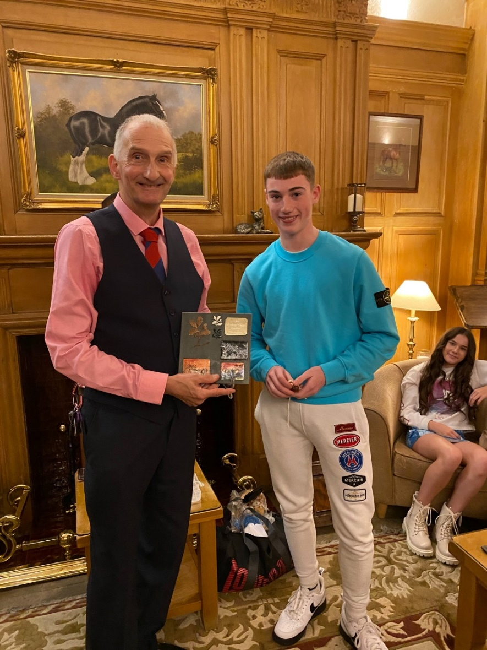
What a busy year 2023 has been!
